**Monitoring of IVY Cluster Backup**

Monitoring of IVY Cluster Automated backup

In the management node open the browser and invoke the following URL

<https://30.0.1.253:9099>

User name : admin

Password : admin

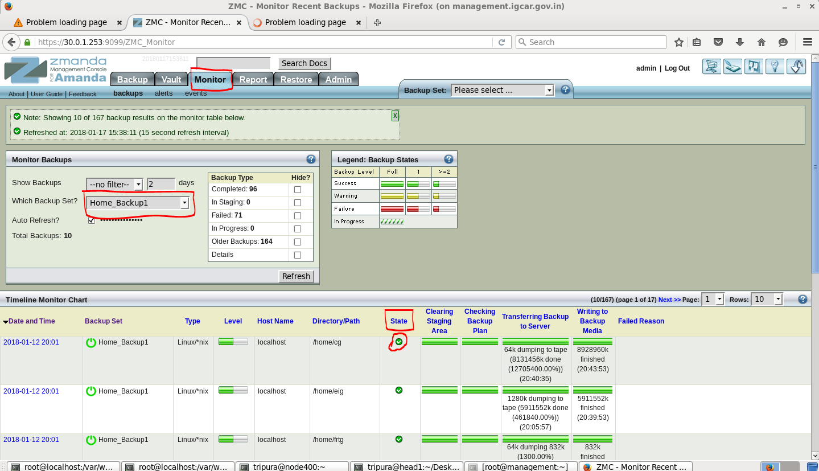

Screenshot of the status of the backup

Click Monitor tab -> Monitor Backups Dialogue box will be opened. On that choose the name of the backup set and click refresh. The status of the backup is shown in screen shot. The green color tick mark in the state field represents the backup is carried out successfully. The red color indicates the failure of the backup. The list of backup set available in automated backup are

* Apps_Backup
* Home_Backup1 (Backup Area : cg,eig,frtg)
* Home_Backup2 (Backup Area : msg,mmg,rdg)
* Home_Backup3 (Backup Area : romg,rpg)
* Home_Backup4 (Backup Area : rseg, sri)

The backup is scheduled on every Friday.